**CHAPTER TWO**

**LITERATURE REVIEW**

**2.0 Introduction**

Literature Review is a summary of previous research on a topic and can also be a part of a larger report of a research project. This chapter explains facts or statements which will be used as guidance in developing the system. It will include reviewing the subject area, past and present technologies, research issues that are currently available, highlights of similar implementation from vendors, review of existing implementations, benefits and challenges of implementations and the trends in the industry or future directions for E-Commerce.

**2.1 Overview of E-Commerce and Online Shopping**

Before setting out a business, one needs to know his target audience or market. These business transactions occur either as business-to-business, business-to-consumer, consumer-to-consumer or consumer-to-business.

Business to consumer (B2C) is business or transactions conducted directly between a company and consumers who are the end-users of its products or services. The business-to-consumer as a business model differs significantly from the business-to-business model, which refers to commerce between two or more businesses. While most companies that sell directly to consumers can be referred to as B2C companies, the term became immensely popular during the dotcom boom of the late 1990s, when it was used mainly to refer to online retailers, as well as other companies that sold products and services to consumers through the internet.

Business to consumer (B2C) is among the most popular and widely known of sales models. The business-to-consumer aspect of electronic commerce (e-commerce) is the most visible business use of the World Wide Web. The idea of B2C was first utilized by Michael Adrich in 1979, who used television as the primary medium to reach out to consumers. Traditionally, B2C referred to mall shopping, eating out at restaurants, pay-per-view and infomercials. However, the rise of the internet created a whole new B2C business channel in the form of e-commerce or selling goods and services over the internet. Online stores and shopping are all examples of B2C.

An online store is a virtual store on the Internet where customers can browse the catalogue and select products of interest. The selected items may be collected in a shopping cart. At checkout time, the items in the shopping cart will be presented as an order. At that time, more information will be needed to complete the transaction. Usually, the customer will be asked to fill or select a billing address, a shipping address, a shipping option, and payment information such as credit card number. An e-mail notification is sent to the customer as soon as the order is placed.

**2.2 Current Research Issues in E-commerce Business**

E-commerce has eliminated a lot of barriers for aspiring business owners. It is easier than ever to set up an online shop and market your goods to shoppers across the globe. But just because it's easy to get into the e-commerce game, doesn't mean it's easy to stay on top. Here are a few common research issues online retailers are facing right now:

### International sales

### Once an e-commerce merchant has established itself as a national retailer, the next frontier is to expand overseas. However, the number of legal and shipping hurdles required to sell internationally have made some smaller businesses hesitant to jump into the global market because other countries have different commerce regulations.

#### **Payment fraud**

One of the biggest concerns today's consumers have is the risk of fraud when they're shopping online. With highly sophisticated malware and savvy cybercriminals, customers' card and bank information can easily be stolen if a merchant doesn't take the proper security measures.

* **Shipping and tracking**

Same and next day delivery, easy tracking options, and hassle-free return policies are just a few of the standards that e-commerce giants have set in place for the industry. Customers have come to expect this level of service, no matter what site they're purchasing from, which places a lot of pressure on small retailers

**2.3 Past technologies that were employed in Ecommerce**

Ecommerce was introduced 40 years ago and, to this day, continues to grow with new technologies, [innovations](https://www.miva.com/ecommerce-software-features?utm_source=organic&utm_medium=blog&utm_content=%E2%80%9Cthe-history-of-ecommerce-how-did-it-all-begin%E2%80%9D), and thousands of businesses entering the online market each year. The convenience, safety, and user experience of ecommerce has improved exponentially since its inception in the 1970’s.

* **1960 – 1982**

Paving the way for electric commerce was the development of the [Electronic Data Interchange](https://www.covalentworks.com/what-is-edi.asp)(EDI). EDI replaced traditional mailing and faxing of documents with a digital transfer of data from one computer to another.  
Trading partners could transfer orders, invoices and other business transactions using a data format that met the ANSI ASC X12, the predominant set of standards in North America.

Once an order is sent, it is then examined by a VAN (Value-Added Network) and finally directed to the recipient’s order processing system. EDI allowed the transfer of data seamlessly without any human intervention.

[Michael Aldrich](https://www.aldricharchive.com/inventors_story.html), an English inventor, innovator and entrepreneur is credited with developing the predecessor to online shopping. The idea came about during a stroll with his wife and Labrador when Aldrich lamented about their weekly supermarket shopping expedition. This conversation sparked an idea to hook a television to their supermarket to deliver the groceries. Immediately after the discussion Aldrich quickly planned and implemented his idea.

In 1979 Aldrich connected a television set to a transaction processing computer with a telephone line and created what he coined, “teleshopping,” meaning shopping at a distance.

* **1982 – 1990**

It was apparent from the beginning that B2B online shopping would be commercially lucrative but B2C would not be successful until the later widespread use of PC’s and the World Wide Web, also known as, the Internet. In 1982, France launched the precursor to the Internet called, [Minitel.](https://www.teleread.com/net-related-tooks-from-search-engines-to-blogware/olpc-lessons-from-minitel/)

The online service used a Videotex terminal machine that was accessed through telephone lines. The Minitel was free to telephone subscribers and connected millions of users to a computing network.

By 1999, over 9 million Minitel terminals had been distributed and were connecting approximately 25 million users in this interconnected network of machines. The Minitel system peaked in 1991 and slowly met its demise after the success of the Internet 3 years later. Eventually, in 2011, France Telecom announced its [shutdown of the Minitel service system](https://www.pcmag.com/article2/0,2817,2389164,00.asp#fbid=-1XmaaLOFxc). Sadly, it had not become what it had hoped to be, the Internet.

* **1990 - 2000**

In 1990 Tim Berners Lee, along with his friend Robert Cailliau, published a proposal to build a “Hypertext project” called, “Worldwide Web.” The inspiration for this project was modeled after the Dynatex SGML reader licensed by CERN.

That same year, Lee, using a NeXTcomputer created the first web server and wrote the first web browser. Shortly thereafter, he went on to debut the web on Aug. 6, 1991 as a publicly available service on the Internet. When Berner’s Lee decided he would take on the task of marrying hypertext to the Internet, in doing that, the process led to him developing URL, HTML and HTTP.

When the National Science Foundation lifted its restrictions on commercial use of the NET in 1991, the Internet and online shopping saw remarkable growth. In September 1995, the NSF began charging a fee for registering domain names.  120,000 registered domain names were present at that time and within 3 years that number grew to beyond 2 million.  By this time, NSF’s role in the Internet came to an end and a lot of the oversight shifted to the commercial sector.

From the beginning, there were many hesitations and concerns with online shopping but the development of a security protocol – the [Secure Socket Layers](https://www.evsslcertificate.com/ssl/ssl-history.html) (SSL) – encryption certificate by Netscape in 1994 provided a safe means to transmit data over the Internet. Web browsers were able to check and identify whether a site had an authenticated SSL certificate and based on that, could determine whether or not a site could be trusted.

Now, SSL encryption protocol is a vital part of web security and version 3.0 has become the standard for most web servers today.

**2.4 Present Technologies Available in Food Ordering and Table Reservations**

Beginning in 2007 with the introduction of the iPhone, to the present day, e-commerce has been transformed yet again by the rapid growth of online social networks, widespread adoption of consumer mobile devices such as smartphones and tablet computers, and the expansion of e-commerce to include local goods and services. The defining characteristics of this period are often characterized as the “social, mobile, local” online world.

E-Commerce business have evolved over the past years with new technologies making online shopping easier for customers.

Disintermediation, Predictive analysis, Real-time customization, one-click checkouts, E-wallets are some of the more prominent innovations that have transformed the e-commerce industry.

**2.4.1 Disintermediation**

Millennials now deal directly with the brands, so it’s only natural that the relationship between end users and brands have becoming less circuitous. These same brands and manufacturers have pull out all the stops to make the sale with the end user (Direct-to-consumer or D2C), to the detriment of their traditional distribution channels, the distributors and merchants.

Conversely, distributors and merchants now cement their relationship with the customer by becoming indispensable and by offering added value: warranties, complementary services and, of course, independence from the brands. This trend, called disintermediation, have taken hold in both B2C and B2B commerce, where automated processes and CRM systems are being used more than ever to maintain relationships and to simplify the ordering process.

**2.4.2 Predictive analysis**

Predictive analysis is a technology that has quickly gained popularity with merchants. By exploiting the massive amount of data (Big Data) collected through interactions and customer profiles or personas, merchants use predictive analysis to better understand consumers’ purchasing habits, preferences, and, yes, even their next purchases, based on the behavior of other customers with similar profiles.

**2.4.3 Real-time customization**

Each shopper now has access to unique content: product recommendations and add-ons chosen based on their preferences, geographic location, market trends, demographic group, past purchases, and brand interactions—all completely automatically. Even better, their next visit is entirely different because it will be based on the previous one and on the merchant’s current promotions.

**2.4.4 One-click checkouts**

Mobile shopping carts are the most popular of the bunch, and are responsible for completing almost half of all sales in ecommerce. The [popularity of mobile couponing](https://www.readycloud.com/info/one-click-savings-a-quick-look-at-2015-mobile-coupon-statistics) is feeding these conversions, but one-click checkouts have become a game-changer in ecommerce because they cater to a user’s behavior and past shopping experience to generate strong conversion thresholds.

**2.4.5 E-wallets**

The upgrades to consumers’ mobile devices and merchants’ point-of-sale systems have spell the end of the traditional wallet for many people now, especially since “mobile” payments are possible using more than just a smart phone—watches, rings, and other devices and “wearables” are now connected and capable of making payments. Merchants have set themselves up to accept these new payment methods.

Payment processors are hopping on the e-wallet bandwagon as quickly as they can. Apple Pay, Samsung Pay, PayPal, Stripe, Google, SlydePay Wallet have made checking out a simpler and more secure now. The biggest hang-up at the present is the lack of integration between retailers. Checkouts have got one-click easier during online shopping than at our favorite brick and mortar stores, restaurants and pharmacies.

**2.5 Highlights of Similar Implementations from Vendors**

There are several implementations of online shops and I would like to highlight ten of them from different vendors and they are:

**2.5.1 Amazon**

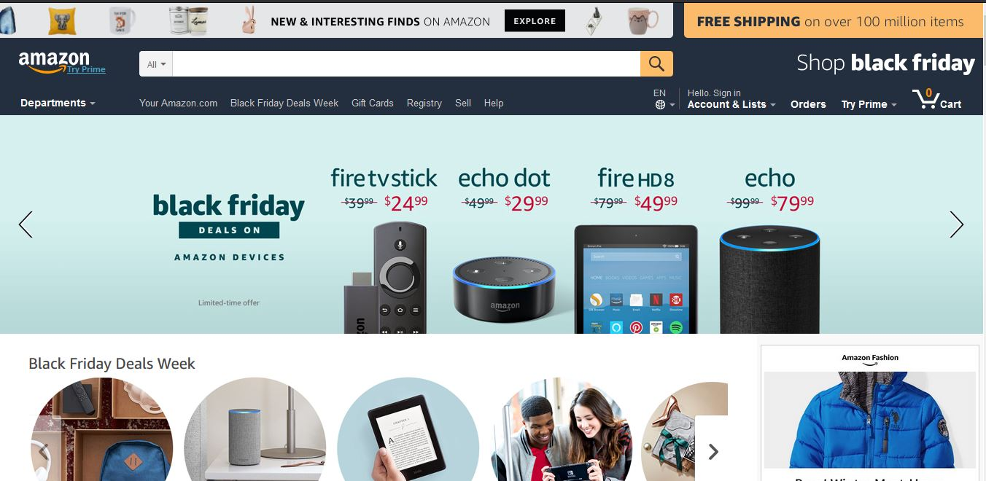

**Amazon.com, Inc.**, [doing business as](https://en.wikipedia.org/wiki/Doing_business_as) **Amazon** is an American [electronic commerce](https://en.wikipedia.org/wiki/E-commerce) and [cloud computing](https://en.wikipedia.org/wiki/Cloud_computing) company based in [Seattle, Washington](https://en.wikipedia.org/wiki/Seattle,_Washington) that was founded by [Jeff Bezos](https://en.wikipedia.org/wiki/Jeff_Bezos) on July 5, 1994. The tech giant is the largest [Internet retailer](https://en.wikipedia.org/wiki/Internet_retailer) in the world measured by [revenue](https://en.wikipedia.org/wiki/Revenue) and [market capitalization](https://en.wikipedia.org/wiki/Market_capitalization), and second largest after [Alibaba Group](https://en.wikipedia.org/wiki/Alibaba_Group) in terms of [total sales](https://en.wikipedia.org/wiki/Total_sales). The amazon.com website started as an online [bookstore](https://en.wikipedia.org/wiki/Bookstore) and later diversified to sell [DVDs](https://en.wikipedia.org/wiki/DVD), [Blu-rays](https://en.wikipedia.org/wiki/Blu-ray), [CDs](https://en.wikipedia.org/wiki/Compact_Disc), [video](https://en.wikipedia.org/wiki/Amazon_Video) downloads/streaming, [MP3](https://en.wikipedia.org/wiki/MP3) downloads/streaming, [audiobook](https://en.wikipedia.org/wiki/Audible.com) downloads/streaming, [software](https://en.wikipedia.org/wiki/Software), [video games](https://en.wikipedia.org/wiki/Video_game), [electronics](https://en.wikipedia.org/wiki/Consumer_electronics), apparel, furniture, food, toys, and jewelry. The company also produces [consumer electronics](https://en.wikipedia.org/wiki/Consumer_electronics)—[Kindle](https://en.wikipedia.org/wiki/Amazon_Kindle) [e-readers](https://en.wikipedia.org/wiki/E-reader), [Fire](https://en.wikipedia.org/wiki/Kindle_Fire) [tablets](https://en.wikipedia.org/wiki/Tablet_computer), [Fire TV](https://en.wikipedia.org/wiki/Fire_TV), and [Echo](https://en.wikipedia.org/wiki/Amazon_Echo)—and is the world's largest provider of [cloud infrastructure](https://en.wikipedia.org/wiki/Cloud_infrastructure) services ([IaaS](https://en.wikipedia.org/wiki/IaaS) and [PaaS](https://en.wikipedia.org/wiki/Platform_as_a_service)). Amazon also sells certain low-end products like USB cables under its in-house brand AmazonBasics.

Amazon has separate retail websites for the United States, the United Kingdom and Ireland, France, Canada, Germany, Italy, Spain, Netherlands, Australia, Brazil, Japan, China, India, and Mexico. In 2016, Dutch, Polish, and Turkish language versions of the German Amazon website were also launched. Amazon also offers international shipping to certain other countries for some of its products.

**2.5.2 Walmart**

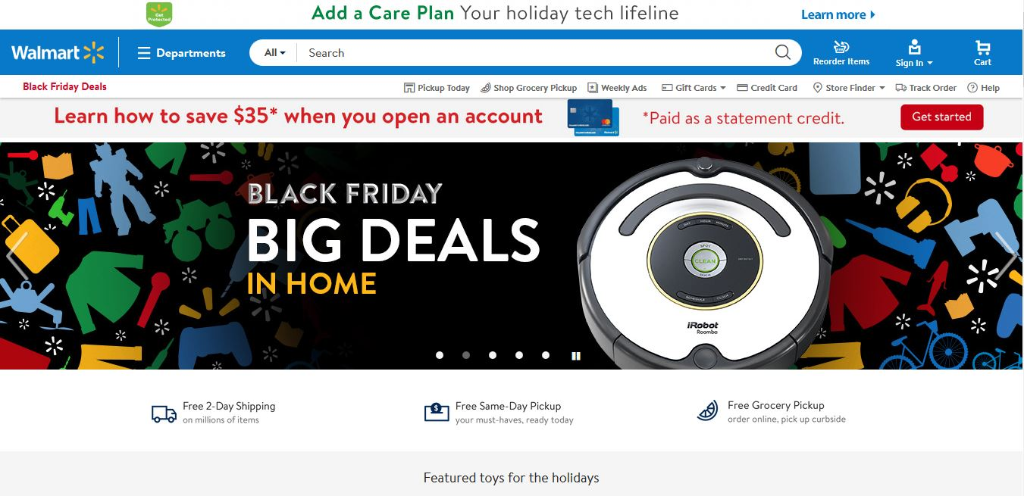

**Wal-Mart Stores, Inc.,** [doing business as](https://en.wikipedia.org/wiki/Doing_business_as) **Walmart**, is an American [multinational](https://en.wikipedia.org/wiki/Multinational_corporation) [retail](https://en.wikipedia.org/wiki/Retail) [corporation](https://en.wikipedia.org/wiki/Corporation) that operates as a [chain](https://en.wikipedia.org/wiki/Chain_store) of [hypermarkets](https://en.wikipedia.org/wiki/Hypermarket), [discount department stores](https://en.wikipedia.org/wiki/Discount_department_store), and [grocery stores](https://en.wikipedia.org/wiki/Grocery_store). Headquartered in [Bentonville, Arkansas](https://en.wikipedia.org/wiki/Bentonville,_Arkansas), the company was founded by [Sam Walton](https://en.wikipedia.org/wiki/Sam_Walton) in 1962 and [incorporated](https://en.wikipedia.org/wiki/Incorporation_(business)) on October 31, 1969. It also owns and operates [Sam's Club](https://en.wikipedia.org/wiki/Sam%27s_Club) [retail warehouses](https://en.wikipedia.org/wiki/Warehouse_club). As of January 31, 2017, Walmart has 11,695 stores and clubs in 28 countries, operating under 63 different names. The company operates under the name Walmart in the United States and Canada. It operates as [Walmart de México y Centro America](https://en.wikipedia.org/wiki/Walmart_de_M%C3%A9xico_y_Centroam%C3%A9rica) in Mexico and Central America, as [Asda](https://en.wikipedia.org/wiki/Asda) in the United Kingdom, as the [Seiyu Group](https://en.wikipedia.org/wiki/Seiyu_Group) in Japan, and as Best Price in India. It has [wholly-owned](https://en.wikipedia.org/wiki/Wholly-owned) operations in Argentina, Chile, Brazil, and Canada.

Walmart is the [world's largest company by revenue](https://en.wikipedia.org/wiki/List_of_companies_by_revenue) – approximately [US$](https://en.wikipedia.org/wiki/US$)480 billion according to the [Fortune Global 500](https://en.wikipedia.org/wiki/Fortune_Global_500) list in 2016 – as well as the [largest private employer](https://en.wikipedia.org/wiki/List_of_largest_employers) in the world with 2.3 million employees.

**2.5.3 Jumia Ghana**

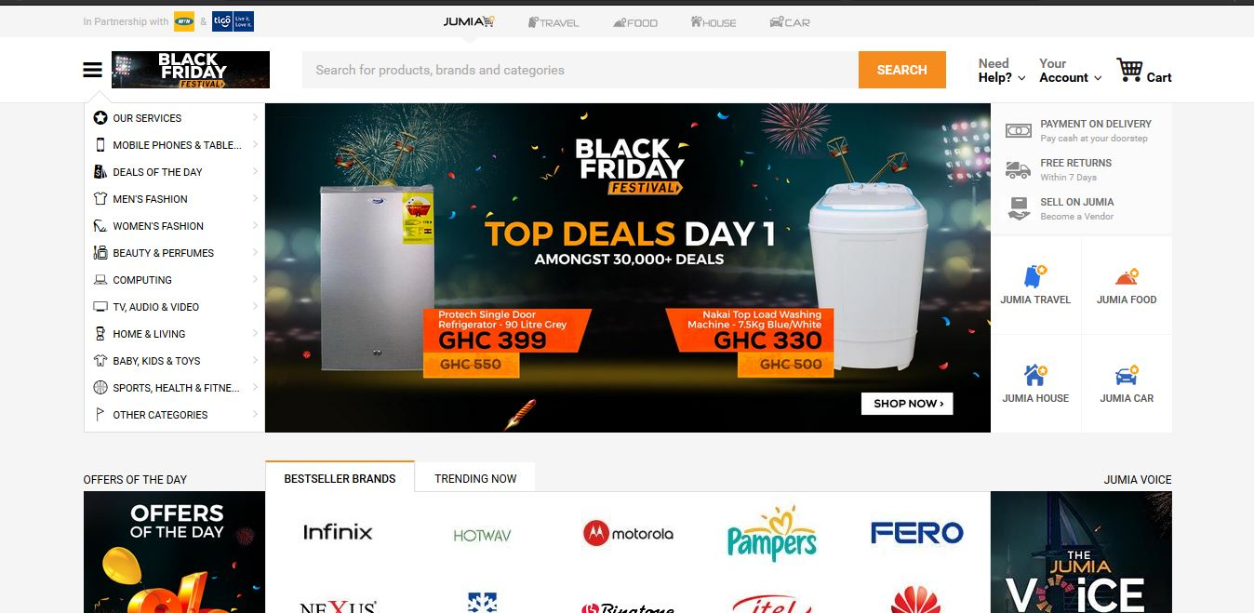

Jumia.com is an open business-to-consumer (B2C) platform enabling businesses to reach Africa's vast and growing consumer market. Jumia.com has established itself as the destination for quality, branded products, catering to an increasingly sophisticated African consumer(s). It is the most visited B2C online retail website in Africa.

 You can shop the widest selection of electronics, fashion, home appliances, kids’ items and more in Ghana and have them shipped directly to your home or office at your  
convenience! They offer free returns and various payment options including cash on delivery. With affordable prices and great products.

**2.5.4 Ahonya**

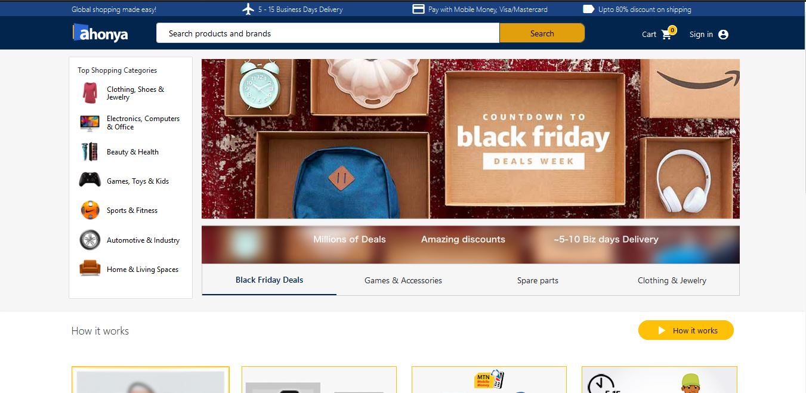

Ahonya.com allows you to shop for genuine electronics and fashion items on US & UK stores and have it delivered to your doorstep.

On www.ahonya.com we have painstakingly selected and listed over 10million products from US & UK stores. Just search and buy the products you love across multiple categories

Find products on any US & UK store, provide us with the link and we will buy and deliver it to you in 5-10 days.

**2.5.5 Azaliabooks**

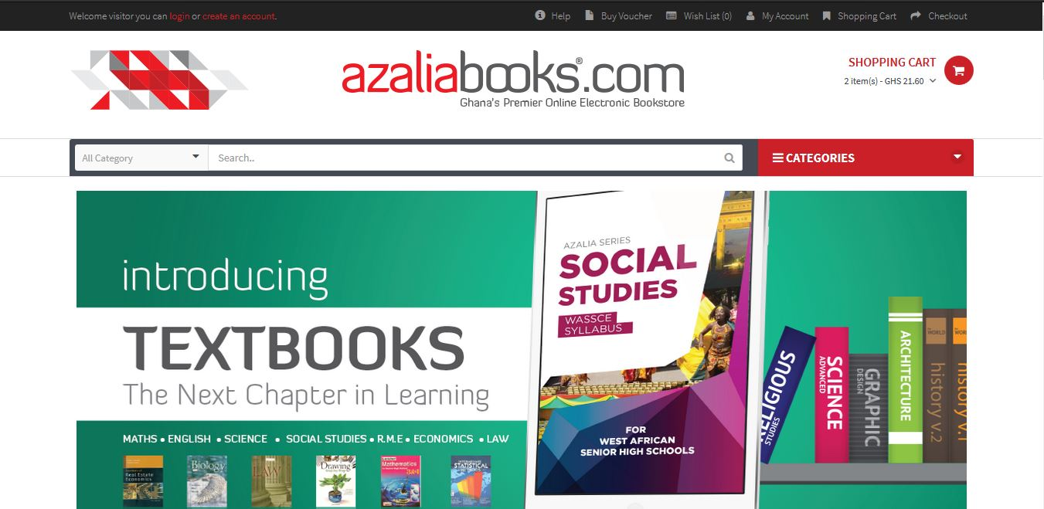

[Azaliabooks.com](http://Azaliabooks.com/) is a website owned and operated by AZALIA. Their sole purpose is to promote the works of writers, publishers, photographers and other professionals in the creative arts industry, in order to explore, inspire and enrich lives. On this website, you can shop for electronic books (e-books) of all genres including educational materials, Christian literature, fiction & non-fiction novels, magazines, newspapers, etc. It also serves as an excellent online market for selling the soft copy of books.

**2.5.6 eShopAfrica**

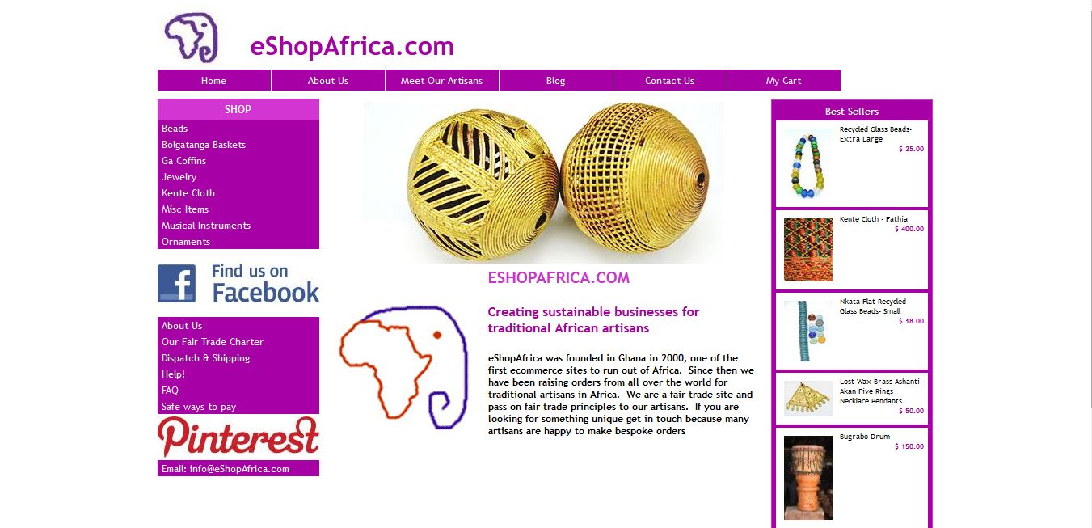

eShopAfrica.com is a fair trade social business creating sustainable businesses for traditional African artisans. Based in Accra, Ghana. eShopAfrica.com has been trading online since 2001 and was one of the first e-commerce sites based in Africa. The company is registered in Ghana as an export only company promoting products from the non-traditional sector. They invest in their artisans enabling them to find new markets and grow their businesses in a sustainable way. Where possible we support artisans from the least developed sectors of society including artisan groups and community organizations.

**2.5.7 Zoobashop**

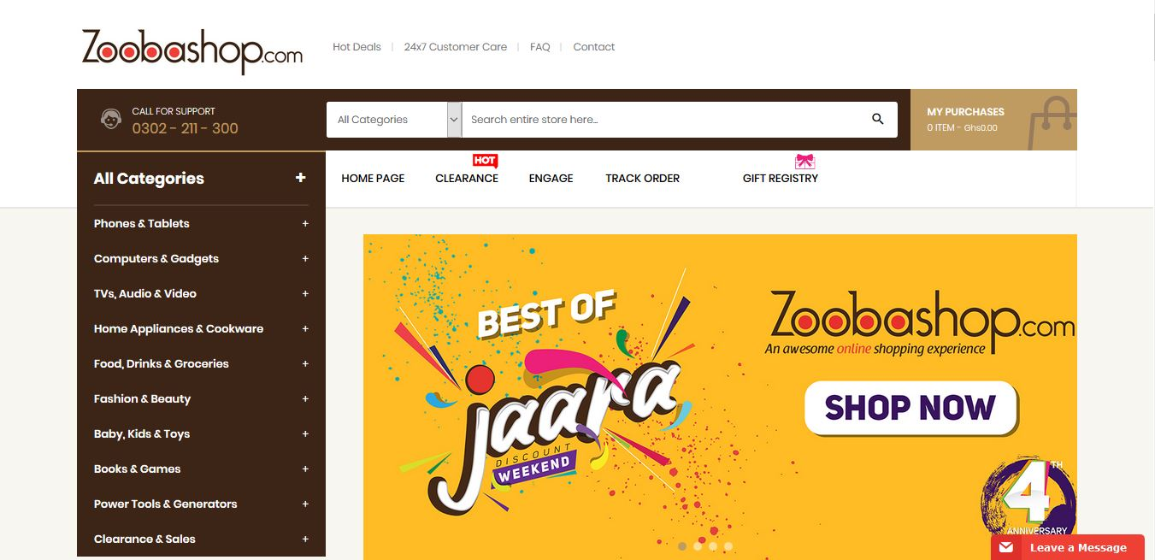

**Zoobashop.com** is a wholly Ghanaian owned online retail. They sell products from different categories  
like electronics, home appliances, fashion, accessories, books, foods, baby products and many more.  
You can shop with your debit & credit cards(Visa & MasterCard branded ATM cards), cash on  
delivery, mobile money among others. Here are some reviews we found about them.

**2.5.8 Telefonika**

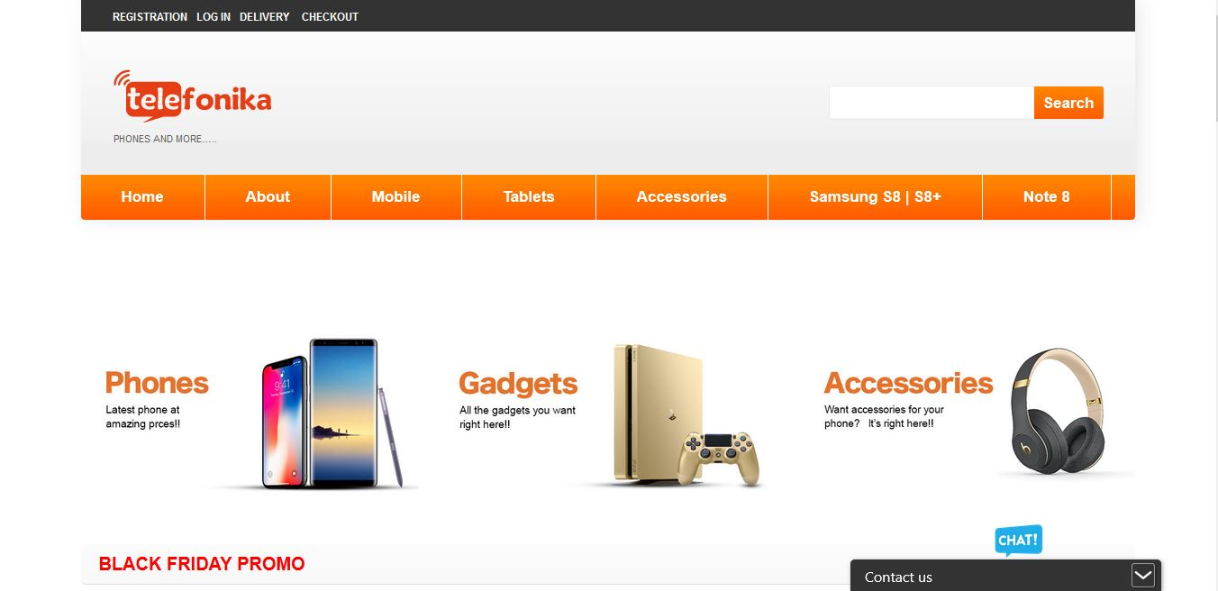

**Telefonika** is a telecommunication company, trading in mobile phones and accessories, telecommunication equipment, electronic products and gadgets which started in the year 2000 in Osu and has grown over the years and now has (10) branches in vantage parts of Accra.

At **Telefonika**, we take pride in paying attention to details and providing after-sale service for all our products and services. Our service center is well staffed with professional technicians from diverse parts of the world, who have been trained and are well versed in mobile telecommunication and IT systems to meet our client needs.

Our focus is beyond phones and accessories; we take value in meeting the needs of our customers. Because we are passionate about our work and our clients, and delivering quality service is our ultimate goal. that is why we have become a household name among individuals and institutions alike.

**2.5.9 Cheki**

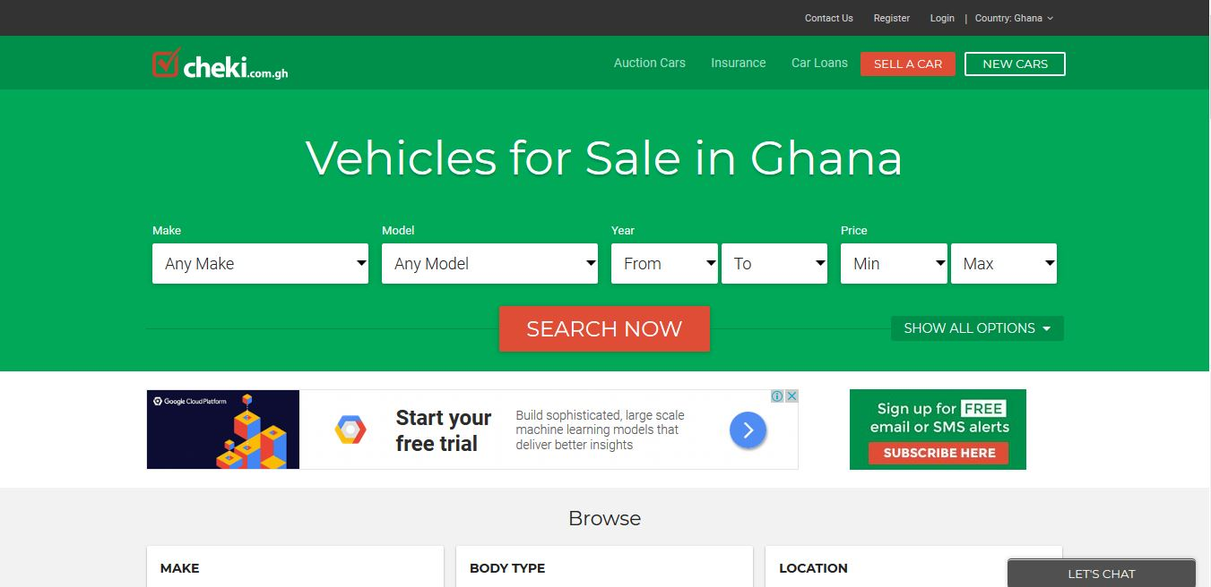

Established in 2010, cheki.com. is Ghana’s #1 Auto website with more car buyers and car sellers than any other site in Ghana.

Cheki.com.gh is an online marketplace where all of Ghana’s leading car dealers, importers and private sellers post their cars for sale in Ghana. They do not sell cars directly but rather offer a state of the art advertising medium for users to buy and sell their cars, 4WDs, vans, bikes and trucks and other vehicles.

They also offer a one stop destination for all buyers of Japanese import cars to Ghana, by centrally hosting all the cars of many leading Japanese car dealers and importers to Ghana.

**2.5.10 Baahe**

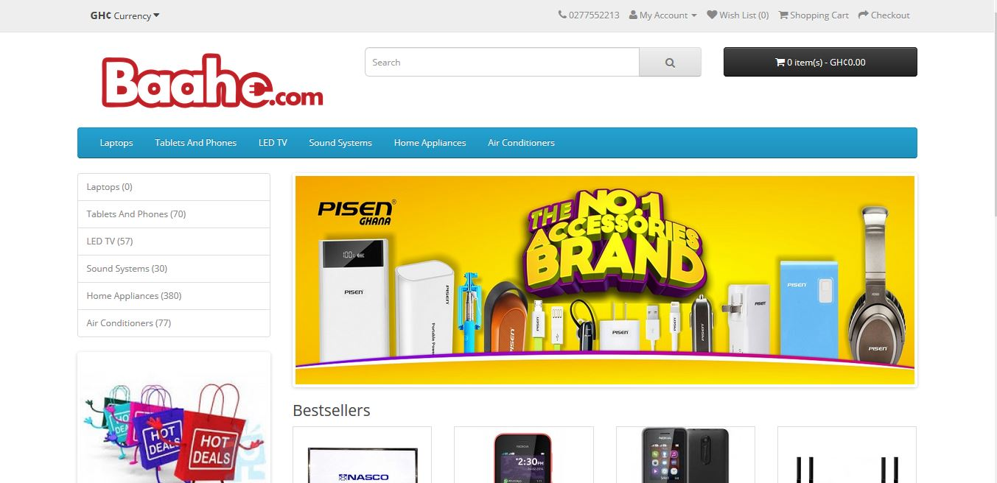

Baahe.com excels in bridging the gap between high quality consumer electronics goods and every consumer in Ghana and beyond. Their mission is to deliver quality consumer electronic goods and appliances right to your doorstep conveniently through our online retail shop. They believe in service to mankind in any possible way therefore our dedication to meeting everyone's electronic needs with prompt and amazing customer service.

**2.6 Review of Existing Implementations (Designs and Features)**

|  |  |  |
| --- | --- | --- |
| **Vendors** | **Design & Features** | **Gap / Limitations** |
| Amazon | * Bi - Lingual (English, Spanish) * Shopping Cart * Checkout * Product recommendations * Payment Gateway * User account * Detailed product description * Customer reviews of the product * Free or competitive shipping options * Advanced navigation and search functions * A fast guest check-out option * Security Features * High-Resolution Photos * Mobile-Friendly * Wish Lists * Special Offers * Live Chat Functionality and Contact Details * Social Media Integration | * No API for developers * Available in only two languages (English and Spanish) |
| Walmart | * Uni-Lingual (English) * Shopping Cart * Checkout * Product recommendations * Payment Gateway * User account * Detailed product description * Customer reviews of the product * Free or competitive shipping options * Advanced navigation and search functions * A fast guest check-out option * Security Features * High-Resolution Photos * Mobile-Friendly * Wish Lists * Special Offers * Live Chat Functionality and Contact Details * Social Media Integration | * No API for developers * Available in only English |
| Jumia Ghana | * Uni-Lingual (English) * Shopping Cart * Checkout * Payment Gateway * User account * Detailed product description * Customer reviews of the product * Free or competitive shipping options * Advanced navigation and search functions * A fast guest check-out option * Security Features * High-Resolution Photos * Mobile-Friendly * Wish Lists * Special Offers * Live Chat Functionality and Contact Details * Social Media Integration | * No API for developers * Available in only English * No product recommendations |
| Ahonya | * Uni-Lingual (English) * Shopping Cart * Checkout * Payment Gateway * User account * Detailed product description * Customer reviews of the product * Free or competitive shipping options * Advanced navigation and search functions * A fast guest check-out option * Security Features * High-Resolution Photos * Mobile-Friendly * Wish Lists * Special Offers * Live Chat Functionality and Contact Details * Social Media Integration | * No API for developers * Available in only English * No product recommendations |
| Azaliabooks | * Uni-Lingual (English) * Shopping Cart * Checkout * Payment Gateway * User account * Detailed product description * Customer reviews of the product * Free or competitive shipping options * Advanced navigation and search functions * A fast guest check-out option * Security Features * High-Resolution Photos * Mobile-Friendly * Wish Lists * Special Offers * Live Chat Functionality and Contact Details * Social Media Integration | * No API for developers * Available in only English * No product recommendations |
| eShopAfrica | * Uni-Lingual (English) * Shopping Cart * Checkout * Payment Gateway * User account * Detailed product description * Free or competitive shipping options * Advanced navigation and search functions * A fast guest check-out option * Security Features * High-Resolution Photos * Mobile-Friendly * Wish Lists * Special Offers * Live Chat Functionality and Contact Details * Social Media Integration | * No API for developers * Available in only English * No product recommendations |
| Zoobashop | * Uni-Lingual (English) * Shopping Cart * Checkout * Payment Gateway * User account * Detailed product description * Customer reviews of the product * Free or competitive shipping options * Advanced navigation and search functions * A fast guest check-out option * High-Resolution Photos * Mobile-Friendly * Wish Lists * Special Offers * Live Chat Functionality and Contact Details * Social Media Integration | * No API for developers * Available in only English * No product recommendations |
| Telefonika | * Uni-Lingual (English) * Shopping Cart * Checkout * Payment Gateway * User account * Detailed product description * Customer reviews of the product * Free or competitive shipping options * Advanced navigation and search functions * A fast guest check-out option * Security Features * High-Resolution Photos * Mobile-Friendly * Wish Lists * Special Offers * Live Chat Functionality and Contact Details * Social Media Integration | * No API for developers * Available in only English * No product recommendations |
| Cheki | * Uni-Lingual (English) * Shopping Cart * Checkout * Payment Gateway * User account * Detailed product description * Customer reviews of the product * Free or competitive shipping options * Advanced navigation and search functions * A fast guest check-out option * Security Features * High-Resolution Photos * Mobile-Friendly * Wish Lists * Special Offers * Live Chat Functionality and Contact Details * Social Media Integration | * No API for developers * Available in only English * No product recommendations |
| Baahe | * Uni-Lingual (English) * Shopping Cart * Checkout * Payment Gateway * User account * Detailed product description * Customer reviews of the product * Free or competitive shipping options * Advanced navigation and search functions * A fast guest check-out option * Security Features * High-Resolution Photos * Mobile-Friendly * Wish Lists * Special Offers * Live Chat Functionality and Contact Details * Social Media Integration | * No API for developers * Available in only English * No product recommendations |

Upon careful analysis of the above implentations from different vendors, I came out with the following findings;

* I realized that almost all the e-commerce sites have these designs and features Shopping Cart, Checkout, Payment Gateway, User account, Detailed product description, Customer reviews of the product, Free or competitive shipping options, Advanced navigation and search functions, fast guest check-out option, Security Features, High-Resolution Photos, Mobile-Friendly, Wish Lists, Special Offers, Social Media Integration, Live Chat Functionality and Contact Details which makes online shopping easier.
* I also realized that almost all e-commerce websites are Uni-Lingual, that is, available in only the English language and they do not provide an interface for other developers to use features of their platform such as product pictures, categories of product in their project.
* I also realized that most of these e-commerce websites in Ghana do not provide product recommendation for customers. This sophisticated additional feature offers good pairings or suggests similar products for users as a means of ‘upselling’ their products. Think about the consumer purchasing a phone who might be persuaded to get a cover or a set of earphones for that phone because **a)** they are already spending money and **b)** it’s a clever pairing. This technique results in extra revenue generation and also helps customers ‘filter’ their choices by perhaps going for something similar to what they’re already looking at.

**2.7 Benefits and Challenges of Implementations**

My main aim is to address some of the shortfalls of the existing systems and to provide a friendlier, robust and reliable service for the e-commerce industry. The system will ensure the following benefits and will also have some challenges:

**2.7.1 Benefits**

* Provide a general-purpose e-commerce store where customers can buy any product (such as books, CDs, computers, mobile phones, electronic items, and home appliances) from the comfort of home through the Internet. The advantage here is that the online shop owners has the flexibility to customize the system to suit the needs of its business.
* Provide a platform for the e-commerce businesses in Ghana to go global so that they can increase their patronage by consumers. This has an added advantage of increasing the revenues of the e-commerce business in Ghana that use my system.
* Provide platform for online shop owners to get their monies before successful order is placed. In this part of our world, if people do not pay before the order is placed, some might end up not showing up for their orders and the shop owners may incur debt. I hope to employ PayPal payment gateway platform to enable customers pay before their orders are placed successfully.
* Provide other developers an easy way around of integrating features of this project such pictures of products, products and categories of product into their own projects using APIs.

**2.7.2 Challenges**

Every implantation has challenges and this project is no exception and some of the challenges of this project are:

* Time to complete this project. This is as a result of the fact that I have to make time for classes and also for developing the project.
* Implementing the mobile money payment system. This is due to the fact that most of these mobile money merchants do not have APIs to make integration of mobile money into my system.

**2.8 Trends in the Industry / Future Direction**

As e-commerce technology continually evolves, customer experience is becoming increasingly essential to the conversion of sales. Some retailers are currently planning to create and sustain customer value by providing sophisticated digital experiences that deliver orders more quickly, blend physical and digital capabilities, and simplify ordering procedures.  Data-as-a service and ecommerce, Chatbots, Drones, droids, augmented reality goggles, Blockchain and bitcoin are some of the more prominent innovations on the horizon that are expected to transform the e-commerce industry.

**2.8.1 Data-as-a-service and ecommerce**

If 92% of Internet users regularly read product reviews and comments from other buyers, it’s because uncertainty is a huge obstacle to online purchasing. The more information there is available about a product (pictures, reviews, descriptions, specifications, etc.), the less reluctant people will be to buy it online. However, constantly refreshing the information on each individual product on a website is a near-impossible task for any merchant who doesn’t have esque resources.

In the future, many retailers will start working with data aggregators that compile data on millions of products: pictures, descriptions, price comparisons, specifications, UPC codes, reviews, and comments. There are even aggregators that contain data on millions of pieces of clothing that can be used to suggest the perfect size! A merchant will be able to link its site to these databases to automatically update product information. Say goodbye to uncertainty and to poor product descriptions!

**2.8.2 Chatbots**

Chatbots otherwise known as messenger bots is a piece of software that can be used by the retailer to chat with customers via text or voice.

In the future, many consumers will have their first interaction with a chatbot, a fully automated chat agent that will answer their questions and act as the first point of contact with the brand. A chatbot increases the number of platforms on which a brand can transact by offering guided, interactive browsing at all times.

Chatbots will soon become as commonplace as automated phone systems, only much more interactive and interesting. At the same time, store sales staff will become more important than ever, as they’ll be increasingly involved in the online experience.

For example, Fast food chain **Taco Bell** unveiled its TacoBot on the popular messaging platform Slack, which allows customers to order food by messaging TacoBot, which asks all the right questions. Also, **Burger King and Pizza Hut** customers can order food directly through Facebook Messenger and Twitter by messaging the restaurant chains’ bots.

**2.8.3 Drone Delivery**

The growing popularity and availability of drone delivery is expected to be one of the most innovative technologies in the retail industry over the next decade. Though regulations (primarily concerning airspace governance) have yet to be established in some parts of the world and are therefore delaying the widespread use of drones, the new delivery system has already played a big role in delivering products to aid disaster relief efforts. The existing delivery technology for these efforts easily translates to the online retail industry, with major retail and delivery companies exploring how they can incorporate drone technology and future e-commerce solutions.

Most drones have a cruising altitude of 400 feet and can fly at roughly 60 miles per hour. Radius distances vary from 10 to 15 miles away depending on the prototype, and drones can generally carry packages up to 5 pounds. In time, drones could enable some companies to offer same-day shipping, or even same-hour delivery in highly populous areas. These faster delivery times along with a growing number of online shoppers worldwide will likely encourage more online purchases in the future.

For example, Australia Post is currently testing drones to commercially deliver parcels to civilian addresses, and sites in the U.S. and Europe have been quick to build airports specifically for drones (internally referred to as “droneports”).

**2.8.4 Droid Delivery**

A more grounded solution, droid delivery is slowly gaining attention as well. Droids are little robots, typically built with six wagon wheels that travel along sidewalks at a pedestrian pace (usually about four miles per hour, though most are capable of speeds more than twice as fast). The most popular delivery droid so far has been created by Starship Technologies, a startup assembled by the founding engineers of Skype. This particular droid weighs between 20 and 30 pounds, is capable of transporting roughly 20 pounds of goods in 30 minutes or less, and is designed to complete the final mile of a delivery. They can climb small sets of stairs, are equipped with nine cameras to stream live video back to their base, a microphone for two-way communication with customers, GPS tracking (for both their base and shoppers), and censors that help it navigate any obstacles or foot traffic on sidewalks. Environmentalists like these little delivery droids because they use less energy than most lightbulbs and because they not only reduce vehicle emissions but are also generally quicker to deliver products. In fact, nearly 30% of transportation costs are incurred during the last mile, when delivery drivers must search for a parking space and leave their car idling while they make the last few steps of the trip walking to the customers’ front door. Delivery droids will make the whole process less expensive and will therefore appeal to retailers and fulfillment companies looking to cut cost and delivery times. Around the world, luxury hotels have implemented delivery droids to boost their hospitality capabilities. For example, hotel droids are able to bring necessities like extra towels, soaps, and even room service meals. In Australia, Domino’s Pizza introduced its own robot to deliver pizzas quickly to customers, avoiding traffic and parking problems.

**2.8.5 Augmented Reality Technology**

In terms of discovering products, retailers have implemented the use of augmented reality to increase online sales. In-home augmented or virtual reality technology comes in the form of headsets or goggles that create an interactive, 3-D shopping experience for the user. It provides retailers an in-home extension of their physical stores and can potentially increase sales with simplistic user experiences and built-in upselling features. Goggle technologies or virtual reality headsets (such as Microsoft HoloLens, Sony Smart Eyeglass, Oculus Rift) are growing in popularity due to their multi-use properties in terms of retail marketing. With goggles, shoppers can look into their mirror at home and transform it into an interactive dressing room. The goggles can then help the shopper choose correct clothing sizes with a virtual view of how the garments will fit as well as suggest matching accessories. By utilizing this technology to accurately choose garment sizes, the percentage of online return shipments may also decrease.

Home design will also be transformed with the use of goggle technologies. Leading furniture companies will be able to display what their products will look like within a shopper’s home and allow the shopper to interact with the furniture in order to choose what styles they like best. For example, a customer will be able to select and visualize a couch, moving it to different sides of the room to see how they like it or even try a different size to make sure it fits in a specific space.

**2.8.6 Blockchain**

Blockchain is essentially a shared ledgering technology that allow companies and their partners to accurately manage and track complex digital transactions, as well as securely store the digital values or objects involved in those transactions. Wal-Mart is one of the first retailers to plan [an international implementation of blockchain](https://www.retaildive.com/news/wal-mart-looks-to-blockchain-for-produce-pork-tracking/432603/) as it looks to impose better tracking of its pork and produce transactions in China.

More retailers, especially the largest international ones, may be ready to use blockchain for similar applications, though doing so requires an embrace of digital economy principles that may still be a stretch for some.

**2.8.7 Bitcoin**

Bitcoin is a digital currency which allows transactions to be performed without banks or any other middlemen. Transactions from consumer’s wallets are processed, verified and publicly recorded by so-called bitcoin enthusiasts. And, there aren’t any transaction fees.

Bitcoin is a new cryptocurrency, which created by an unknown programmer (or a group of programmers) under the pseudonym Satoci Nakamoto. This happened in 2009. Nobody knows where this man is and what his name is in the real world. Cryptocurrency Bitcoin has the basic functions and properties of conventional money from different countries. It could exchange, stored and used to purchase. However, Bitcoin is cryptocurrency, which is a type of digital currency. Its emissions and accounting based on different cryptographic methods. A decentralized operation occurs, in a distributed computer network. Cryptocurrency - this is the real software, the growth rate of which depends on supply and demand, not by subsequent investors. Each member of the network can make instant transactions cryptocurrency without intermediaries. That is, the buyer sends the money directly to the seller. No need to go to the bank, you simply send Bitcoins to the person. Coins in the system are the cryptographic (mathematical) hash functions. Each of them is completely unique and cannot be used twice. Bitcoin can be used to purchase goods and services on the Internet anonymously. Moreover, it is easier and cheaper to make international payments because Bitcoin is not tied to a particular country. To store Bitcoins, have a few options. Offline purse is being installed and is created on your PC. Usually, it is encrypted to prevent tampering. But, there are some cons, if you forget the password to log into a purse or on your computer hard drive died you lost your money. Online Bitcoin wallet has advantages over the offline version. You can access it using not only PCs but also tablet or phone. One of the main problems of these wallets is that all the data stored on the server. Many online stores or retail outlets that accept bitcoin currency side by side with local currency, debit cards or credit cards, opens the window of opportunity for users to compare the benefits of shopping via bitcoin payment.

**2.9 Summary**

In this chapter, I started with the overview of the subject area which is Ecommerce and online shopping. I proceeded with current research issues in Ecommerce business. I then took a look at the technologies available both past and present and later reviewed and highlighted similar implementations from ten vendors namely **Amazon.com,Walmart.com,Jumia.com, Ahonya.com,Azaliabooks.com,eShopAfrica.com,Zoobashop.com,Telefonika.com,Cheki.com and Baahe.com.** I went further to look at the benefits and challenges of my implementation and finally concluded with the trends and Future Direction in the ecommerce business.